**#Form đăng nhập**

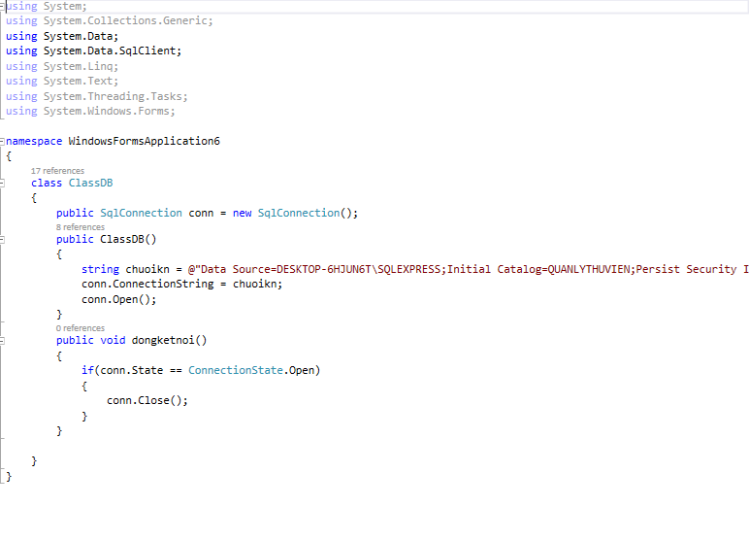

**A screenshot of a cell phone

Description generated with very high confidence**

**Code:**

using System;

using System.Collections.Generic;

using System.ComponentModel;

using System.Data;

using System.Data.SqlClient;

using System.Drawing;

using System.Linq;

using System.Text;

using System.Threading.Tasks;

using System.Windows.Forms;

namespace WindowsFormsApplication6

{

public partial class Form1 : Form

{

public Form1()

{

InitializeComponent();

}

public static string _manhanvien;

public bool ktdn(string Username, string Password)

{

ClassDB kn = new ClassDB();

string sql = "select manhanvien from nhanvien where manhanvien='" + Username

+ "' AND matkhau='" + Password + "'";

SqlDataAdapter da = new SqlDataAdapter(new SqlCommand(sql, kn.conn));

DataTable dt = new DataTable();

da.Fill(dt);

if (dt.Rows.Count > 0)

{

return true;

}

else return false;

}

private void button1_Click(object sender, EventArgs e)

{

ClassDB kn = new ClassDB();

string sql = "select manhanvien from NHANVIEN where tendangnhap='"+txtDN.Text+"' and matkhau='"+txtMK.Text+"' UNION select madocgia from DOCGIA where madocgia = '"+txtDN.Text+"' and matkhau = '"+txtMK.Text+"'";

SqlDataAdapter da = new SqlDataAdapter(new SqlCommand(sql, kn.conn));

DataTable dt = new DataTable();

da.Fill(dt);

if (dt.Rows.Count > 0)

{

MessageBox.Show("Thanh cong");

_manhanvien = dt.Rows[0][0].ToString();

Menu fm = new Menu();

fm.Show();

this.Hide();

}

else MessageBox.Show("That bai");

}

private void btnRS_Click(object sender, EventArgs e)

{

txtDN.Clear();

txtMK.Clear();

txtDN.Focus();

}

}

}

**#Form menu**

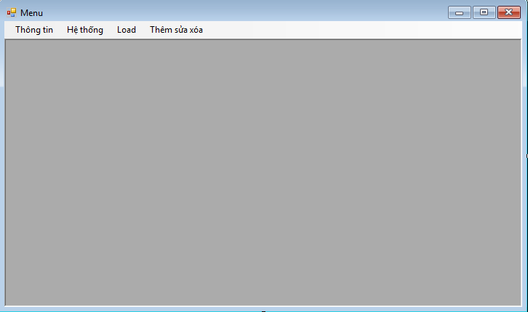

**Code:**

using System;

using System.Collections.Generic;

using System.ComponentModel;

using System.Data;

using System.Drawing;

using System.Linq;

using System.Text;

using System.Threading.Tasks;

using System.Windows.Forms;

namespace WindowsFormsApplication6

{

public partial class Menu : Form

{

public Menu()

{

InitializeComponent();

}

private void thôngTinSinhViênToolStripMenuItem_Click(object sender, EventArgs e)

{

}

private void tìmKiếmToolStripMenuItem_Click(object sender, EventArgs e)

{

ThongTinSV TT = new ThongTinSV();

TT.MdiParent = this;

TT.Show();

}

private void đăngXuấtToolStripMenuItem1_Click(object sender, EventArgs e)

{

this.Close();

Form1 fm = new Form1();

fm.Show();

}

private void thôngTinSinhViênToolStripMenuItem1_Click(object sender, EventArgs e)

{

TTTK tk = new TTTK();

tk.MdiParent = this;

tk.Show();

}

private void Menu_Load(object sender, EventArgs e)

{

}

}

}

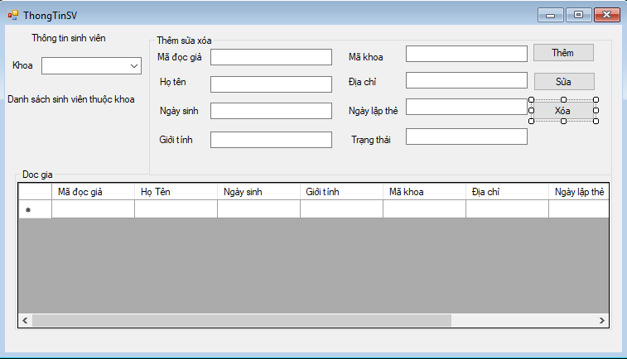

**#Form ThôngTinSV**

using System;

using System.Collections.Generic;

using System.ComponentModel;

using System.Data;

using System.Drawing;

using System.Linq;

using System.Text;

using System.Threading.Tasks;

using System.Windows.Forms;

using System.Data;

using System.Data.SqlClient;

namespace WindowsFormsApplication6

{

public partial class ThongTinSV : Form

{

public ThongTinSV()

{

InitializeComponent();

}

private void label3_Click(object sender, EventArgs e)

{

}

private void ThongTinSV_Load(object sender, EventArgs e)

{

ClassDB db = new ClassDB();

string sql = "SELECT makhoa, tenkhoa FROM KHOA";

SqlDataAdapter da = new SqlDataAdapter(new SqlCommand(sql, db.conn));

DataSet ds = new DataSet();

da.Fill(ds);

cbKhoa.DataSource = ds.Tables[0];

cbKhoa.DisplayMember = "tenkhoa";

cbKhoa.ValueMember = "makhoa";

}

private void cbKhoa_SelectedIndexChanged(object sender, EventArgs e)

{

ClassDB db = new ClassDB();

string sql = "SELECT * FROM DOCGIA WHERE makhoa = '"+cbKhoa.SelectedValue.ToString()+"'";

SqlDataAdapter da = new SqlDataAdapter(new SqlCommand(sql, db.conn));

DataTable dt = new DataTable();

da.Fill(dt);

dgSV.DataSource = dt;

}

private void dgSV_CellClick(object sender, DataGridViewCellEventArgs e)

{

txtMADG.Text = dgSV[0, e.RowIndex].Value.ToString();

txtHT.Text = dgSV[1, e.RowIndex].Value.ToString();

txtNS.Text = dgSV[2, e.RowIndex].Value.ToString();

txtGT.Text = dgSV[3, e.RowIndex].Value.ToString();

txtMK.Text = dgSV[4, e.RowIndex].Value.ToString();

txtDC.Text = dgSV[5, e.RowIndex].Value.ToString();

txtNLT.Text = dgSV[6, e.RowIndex].Value.ToString();

txtTT.Text = dgSV[8, e.RowIndex].Value.ToString();

}

private void button1_Click(object sender, EventArgs e)

{

ClassDB db = new ClassDB();

string sql = "insert into docgia values('" + txtMADG.Text + "', '" + txtHT.Text + "', '" + txtNS.Text + "', '" + txtGT.Text + "', '" + txtMK.Text + "', '" + txtDC.Text + "', '" + txtNLT.Text + "',' ', '" + txtTT.Text + "')";

if((new SqlCommand(sql, db.conn)).ExecuteNonQuery() > 0)

{

MessageBox.Show("Them thanh cong");

}else MessageBox.Show("Them khong thanh cong");

ThongTinSV_Load(sender,e);

}

private void button3_Click(object sender, EventArgs e)

{

ClassDB db = new ClassDB();

string sql = "DELETE FROM docgia WHERE madocgia='"+txtMADG.Text+"'";

if ((new SqlCommand(sql, db.conn)).ExecuteNonQuery() > 0)

{

MessageBox.Show("Xoa thanh cong");

}

else MessageBox.Show("Xoa khong thanh cong");

ThongTinSV_Load(sender, e);

}

}

}

**A screenshot of a cell phone

Description generated with very high confidence**

**#Form thông tin tài khoản**

using System;

using System.Collections.Generic;

using System.ComponentModel;

using System.Data;

using System.Data.SqlClient;

using System.Drawing;

using System.Linq;

using System.Text;

using System.Threading.Tasks;

using System.Windows.Forms;

namespace WindowsFormsApplication6

{

public partial class TTTK : Form

{

public TTTK()

{

InitializeComponent();

}

private void groupBox1_Enter(object sender, EventArgs e)

{

}

private void label5_Click(object sender, EventArgs e)

{

}

private void TTTK_Load(object sender, EventArgs e)

{

ClassDB db = new ClassDB();

string sql = "SELECT manhanvien, hoten, diachi, tendangnhap FROM NHANVIEN WHERE manhanvien='"+Form1._manhanvien+ "' UNION SELECT madocgia, hoten, diachi, madocgia FROM DOCGIA WHERE madocgia = '" + Form1._manhanvien + "'";

SqlDataAdapter da = new SqlDataAdapter(new SqlCommand(sql, db.conn));

DataTable dt = new DataTable();

da.Fill(dt);

txtMa.Text = dt.Rows[0][0].ToString();

txtHoTen.Text = dt.Rows[0][1].ToString();

txtDC.Text = dt.Rows[0][2].ToString();

txtTDN.Text = dt.Rows[0][3].ToString();

}

private void button1_Click(object sender, EventArgs e)

{

ClassDB db = new ClassDB();

string sql = "UPDATE NHANVIEN SET hoten='"+txtHoTen.Text+"',diachi='"+txtDC.Text+"',tendangnhap='"+txtTDN.Text+"' WHERE manhanvien='"+Form1._manhanvien+"'";

if((new SqlCommand(sql, db.conn)).ExecuteNonQuery() >0)

{

MessageBox.Show("Cap nhat thanh cong");

}

else MessageBox.Show("Cap nhat khong thanh cong");

}

}

}